Abstract

Masks have a special relevance for the study of facial perception and can in turn be illuminated by the methods appropriate to it. This presentation at the 2009 Body and Mask in Ancient Theatre Space Conference endeavoured to document some of these issues, using in particular Principal Components Analysis (PCA) of 3D scanned data of ancient mask artefacts.

Note on contributors to the work: the PCA markup and output was undertaken by collaborators in the Psychology Department at Glasgow University, under the direction of Professor Mike Burton. Dr. Martin Blazeby, digital artist with the Body and Mask project team contributed to the scanning and processing of 3D data, under the direction of the Project Director, Professor Richard Beacham and co-Director, Dr. Hugh Denard, of King’s Visualisation Lab, King’s College London.

Why were miniature masks so popular as objects and elements in material culture in antiquity? The explanation is perhaps not simply the popularity of the theatre within that culture, but also a fascination with these very distinctive faces, and with what is involved in their apprehension. A mask on a lamp is not merely a reference to remind one of an experience in the theatre, but a theatrical object detached and recontextualised. Abstracted, it becomes a passive object for inspection, into which memories can be channelled to invest it with a new aura, that of a static object, rather than that of the active tool of transformation, inhabited by a succession of performers. That process encourages us to think about what is involved in the perception of a face, and what can be learned from work in the facial perception discipline that is relevant to the ancient mask (and, where relevant, the converse).

On one quite basic level this might involve the differentiation of male and female faces. Without the guidance of hairstyle, an object such as Fig 1 is liable to be read as male, although the trace of hair that remains is not incompatible with a female tragic onkos mask (and specifically the example preserved in Cefalu, illustrated by Brea 1981, 121). Modern research has of course accurately documented in 3D the variations of thickness between male and female face in different areas (such as the chin and temples), offering the potential to disambiguate indeterminate masks such as 1BT 11 and 2TT 6 (see Bruce and Young 1998, 103-5).

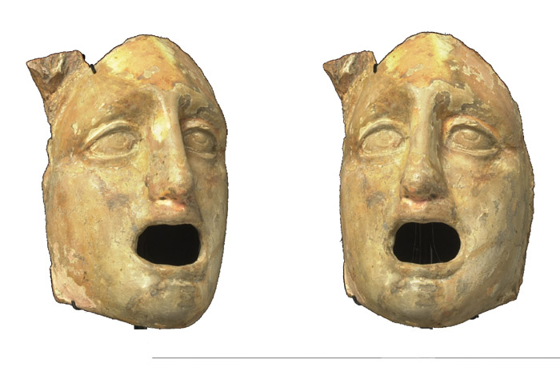

Figure 1 Tragic mask from Lipari, Art Gallery and Museum, Kelvingrove, Glasgow

The symmetry of the face is another relevant area, important both in studies of attractiveness, and in the effect of injury to one brain hemisphere on perception (cf. Bruce and Young, 1998, 137-40 and 231-34). Whereas perfect symmetry has been shown to be desirable in the real world, the maskmaker seeks more or less subtle asymmetries to create a lifelike illusion when the mask is animated. In the slave masks there are, of course, quite extreme variations, especially in the brows, but even in the most aestheticised free characters there are telling asymmetries of both external and internal features. The Panchrestos from Lipari at Kelvingrove, Glasgow, is shown here first in a veridical image (Fig. 2), and then (Figs. 3-4) with perfectly symmetrical features that have been created by flipping over first one and then the other half of the face. Two quite different ‘characters’ are created thereby, one more aggressive, the other (from mirroring the left side of the face) displaying surprise. The eyelid shapes in particular can be seen to differ considerably in each half of the face, although this is not at all obvious when viewing the veridical image.

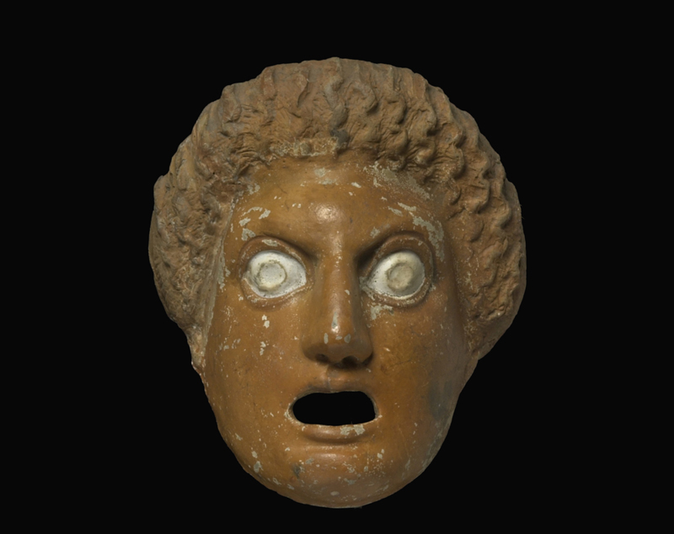

Fig. 2 Mask of a youth from Lipari (Brea’s Panchrestos 1 – Brea 1981, 158f.) Art Gallery and Museum, Kelvingrove, Glasgow

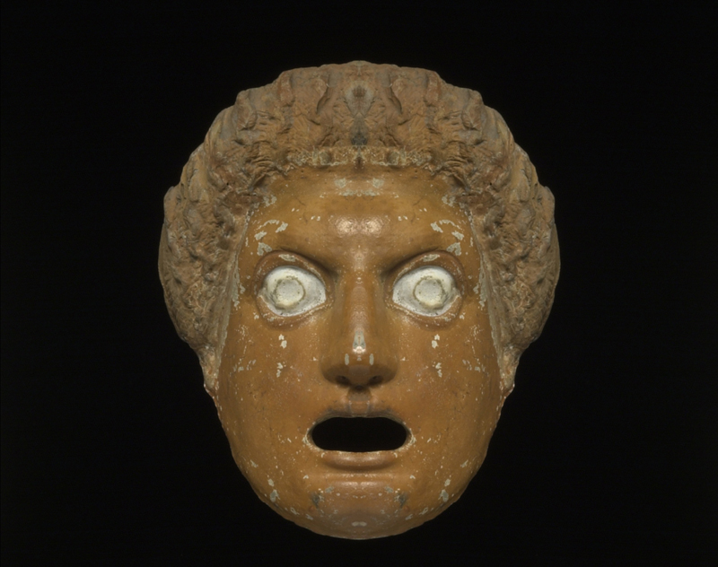

Fig. 3 Symmetrical face created by mirroring the right hand side of the face from Fig. 2

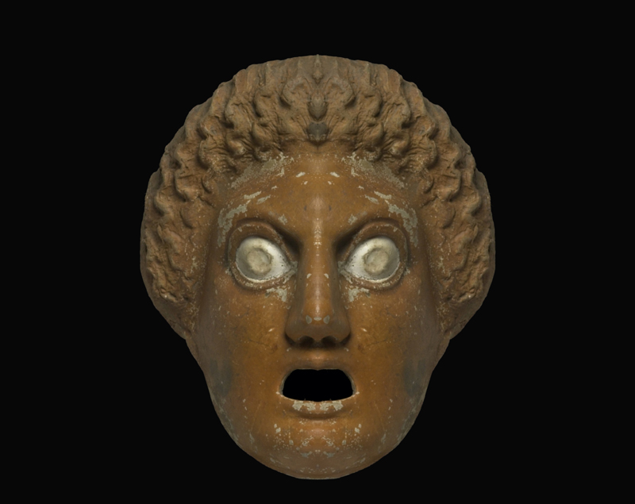

Fig. 4 Symmetrical face created by mirroring the left hand side of the face from Fig. 2

Existing categorisations of the masks have arrived at very different conclusions – there is for example little agreement between Brea and Cavalier’s assessment of the Lipari masks and that of MNC. One explanation may be the lack of consideration of the science of facial perception. It is true that most of the discriminants adduced by Pollux relate to key internal features such as brows and also to the external feature of hairstyle. But (as transmitted in the epitome) these are far too sketchy to identify the artefacts, and even if they were more extensive it may be doubted that they would do so, since they relate to only a small part of the processes involved in facial perception. While far from completely understood, it is clear from the research that a battery of processing techniques is simultaneously deployed, including not only the individual characteristics of internal features, but also their configural relations (such as relative distances of eyes and mouth), and ‘holistic’ processing of the face (including both internal features and external volumes). The techniques for extracting the information are also multiple, with 3D strereopsis employed, but (surprisingly) less critically than 2D ‘shape from shading’. If we aim to document similarities and relationships in the population of faces in the surviving ‘monuments’, we need to take account of all these processes; it will not suffice to say that a mask has ‘level brows’ or ‘wavy hair’. We should understand that the internal features cannot be considered in isolation from each other, or from the face as a totality, and that this explains a phenomenon well known to sculptors of masks: that when the modelling of one feature is changed, the other features and the face as a whole appear to change with it.

The display and perception of emotions is another important area in the studies of facial perception. Whether one subscribes entirely to Ekman and Friesen’s FACS model (Facial Action Coding System - Ekman and Friesen, 1978), or to variant or competing formulations (cf. Bruce and Young, 1998, 187-204), the role of different muscles in the lower and upper parts of the face in displaying signs of emotions is well documented (see also e.g. Hjortsjö, 1969). Yet the unequivocal display of one dominant emotion would unproductive for maskwork, where it is desirable to simulate changing emotions. In the idealised high-status masks it seems, accordingly, that there is both an ambiguity between emotional states, depending on the aspect of the mask, and that the emotions that are encoded are at a more restrained level than Ekman’s paradeigmatic faces: there is thus both a mixture of states, and an anticaricaturing process, which approximates the emotional display more towards a neutral expression. In the grotesque masks, however, a different process occurs. The typical features of the slave mask are the twisted and furrowed brows, which allow the mask to show worry when lowered, and the large semicircular mouth and beard which produce a happy expression when the mask is raised. Each of these in fact resembles a positive caricaturing of one part of the relevant facial display from Ekman’s models, as may be seen from Figs. 5 and 6. In the top row of Fig 5, the central face is Ekman’s ‘Happiness’, flanked by a computer-generated negatively caricatured (or anticaricatured) version (left), and a positive caricature (right). The bottom row shows ‘Fear’, again with negative and positive caricatures. Montaging together the lower part of the ‘happy’ face and the upper part of the ‘fearful’ face (Fig 6) produces a composite that noticeably resembles the ancient slave mask. The resemblance is strongest, however, in the positively caricatured version (right), where both eyes and mouth are further enlarged, and the twisting of the brows is still more apparent. (The middle row, showing Surprise, noticeably evokes masks of youths such as that of Fig. 2 above, and it will be seen that in the positively caricatured version the enlarged eyes and mouth more closely resemble those of the masks). What is distinctive, it appears, about slave masks is that they have inscribed on them an impossible combination of contradictory facial expressions, and this, it may be suggested, is why slave masks are inherently (in both senses) ‘funny’.

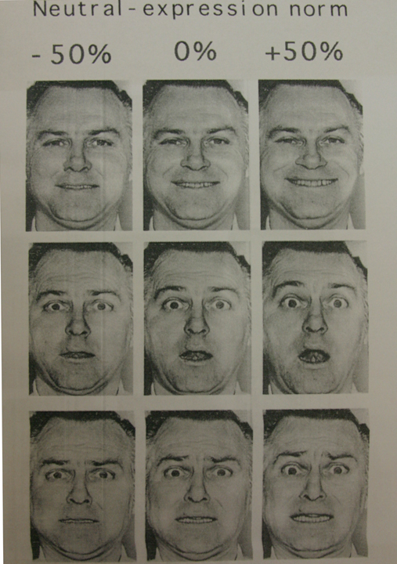

Fig. 5 caricatured (right column) and anticaricatured (left column) versions of Ekman and Friesen’s facial expressions for (top to bottom) Happiness, Surprise and Fear, reproduced by Bruce and Young (1998), 201 from Calder et al. 1997.

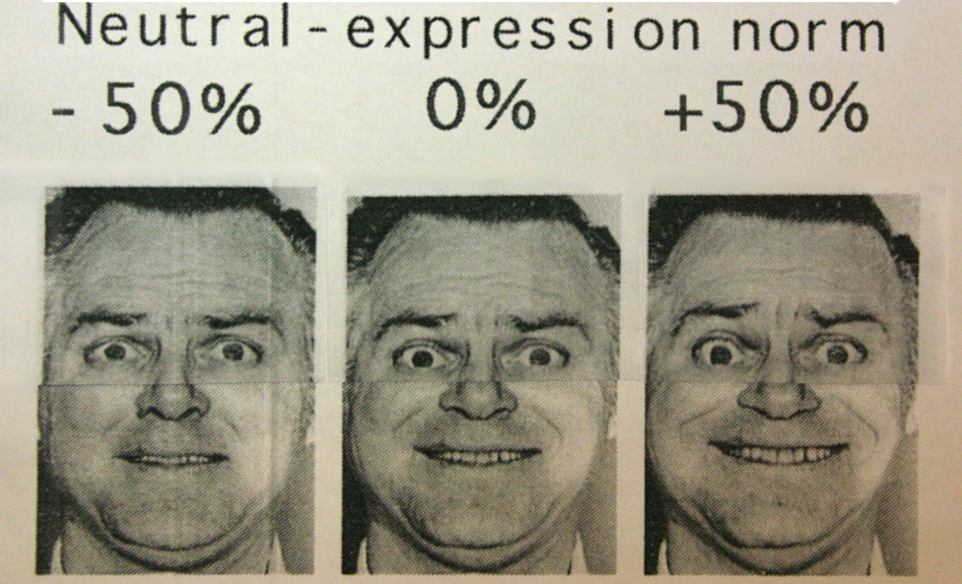

Fig. 6 montage of the upper half of the faces showing Fear from Fig. 5 above with the lower half of the faces showing Happiness.

One way to express economically the range of variation in a dataset is through Principal Components Analysis (PCA). Whether applied to literary texts or (as here) to the shapes of objects, PCA extrapolates from the data an infinite number of dimensions, in order of diminishing significance. In the use of PCA for the facial perception discipline, faces are marked up with around 80 individual points which represent the positions of both external and internal features. The software establishes the average position of each of these points across the dataset, and then calculates the individual dimensions of variation from them, each of which has both a positive and negative extreme. Thus in the screenshot below (Fig. 7), the left window shows the average of the points in the dataset, and the centre and right windows show the extremes of the first component. Even in this ‘wireframe’ mode, it is evident that the extreme of the dimension in the centre window emphasizes elements that relate to slave masks, with bulging eyes, insect-like, rising high into the upper face, while the gaping slave mouth fills the lower half.

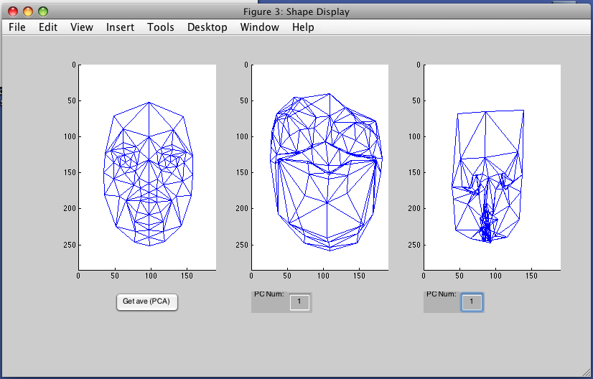

Fig. 7 Extremes of Component 1 (centre and right) and averaged points (left) of a dataset of tragic and comic masks

In Component 2 (Fig 8 below), the slave face is again clearly discernible, but in a less caricatural form, at the negative end of the dimension (right), while in contrast the wireframe of the positive extreme (centre) hints at an idealised form. It is clear, then, that (as one might expect) the grotesque/idealised contrast that is fundamental to the genera of the ancient mask is strongly encoded in at least the first and second dimensions.

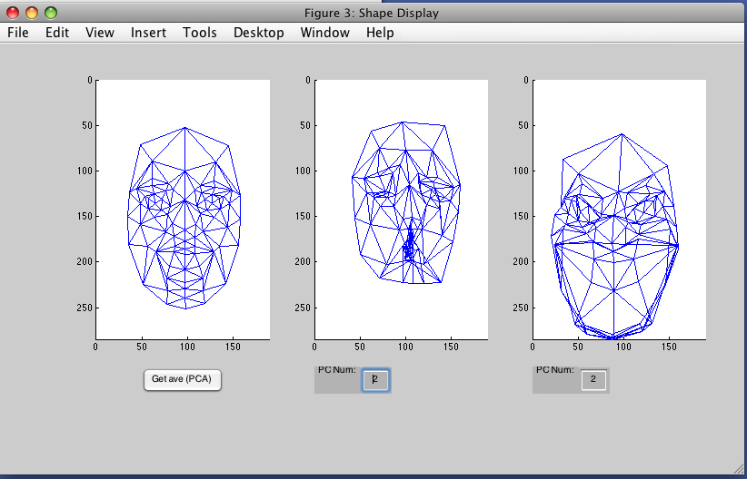

Fig. 8 Extremes of Component 2 (centre and right) and averaged points (left) of a dataset of tragic and comic masks

From the subsequent dimensions other types of contrast can be seen, which relate not so much to the genera of the masks but perhaps more to shapes that can be exhibited in the modelling of any of them. Thus the third (below, Fig. 9) and fourth Components show contrasts of ‘short and rounded’ against ‘tall and oblong’, while in lower order Components such as Component 6 (Fig. 10) further possibilities such as vertical shear of the face (with consequent asymmetries of the jawline) are exhibited.

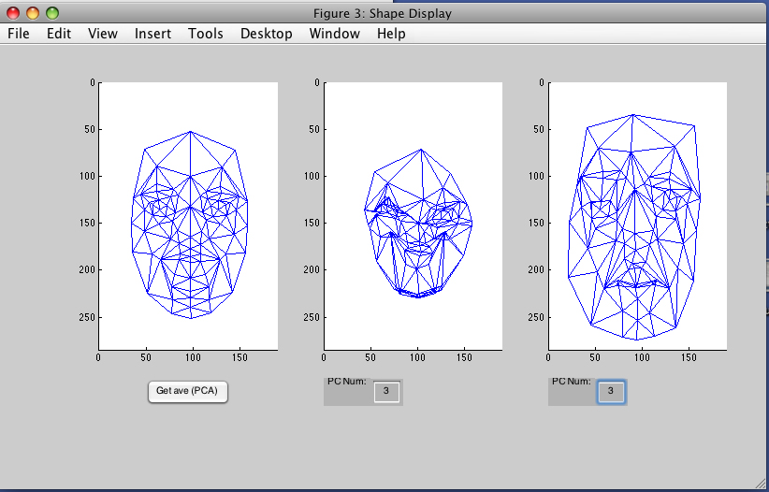

Fig. 9 Component 3

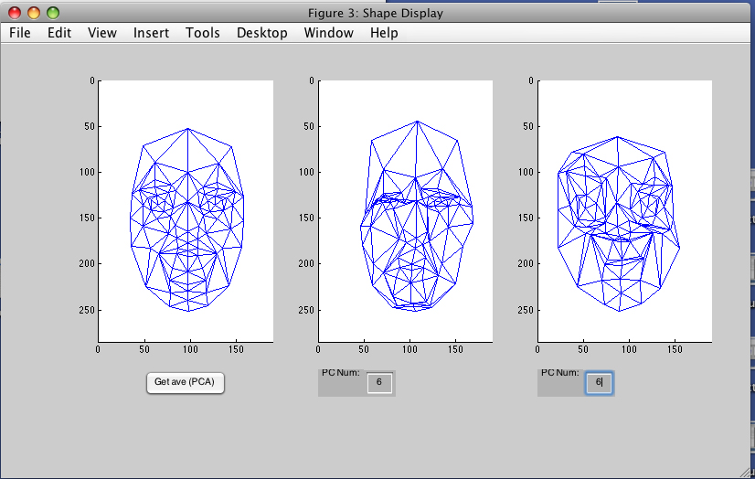

Fig. 10 Component 6

To understand the nature of these dimensions better, they may be applied in turn to individual faces from the dataset. Consider for example a tragic mask from the British Museum (UT46 in Monuments Illustrating Tragedy and Satyr Play, ed.2). In Fig. 11 the monochrome texture file has been mapped in the left window to the average of the co-ordinates, and in the right window to the positive extreme of Component 1. While the ‘averaged’ face is flat and lifeless, the face mapped to the Component is a plausible mask, noble in appearance, but arguably less ‘tragic’ than the real artefact. The face is ‘switched-on’ and attentive, but in a less profound manner than the original, reflecting (it may be) the adolescent self-absorption of the masks of young men in the dataset.

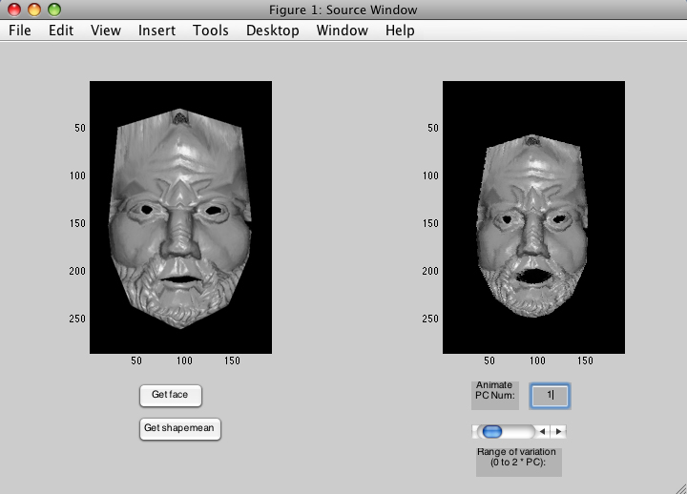

Fig. 11 Tragic mask UT 46 (British Museum) mapped (left) to average co-ordinates of the dataset, and (right) to positive extreme of Component 1

What is the antithesis of this extreme of Component 1? It is, consistent with what was seen in the wireframe view, a very characteristic and ‘sculptural’ slave mask. We see from the contrast of these two extremes just what is involved in the transformation from idealised to grotesque: the fattening of the lips, the shortening of the nose, the compression of the brow and enlargement and displacement or the eyes. But we can also discern, from comparison with the ‘averaged’ face, something of what is involved in the process of converting a ‘real-world’ face to one that is engaged and attentive, as a mask must be (and as a real human face, for the majority of the time, is not).

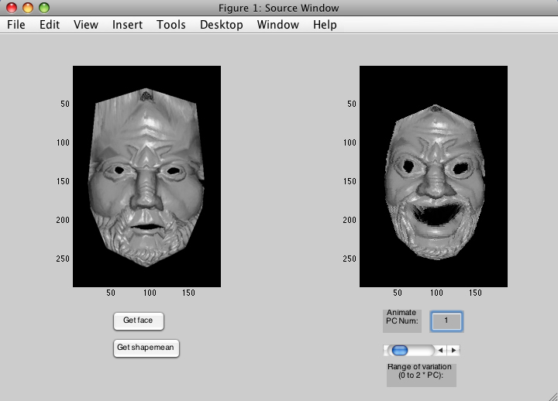

Fig. 12 Tragic mask from Fig 11 mapped (left) to average co-ordinates of the dataset, and (right) to negative extreme of Component 1

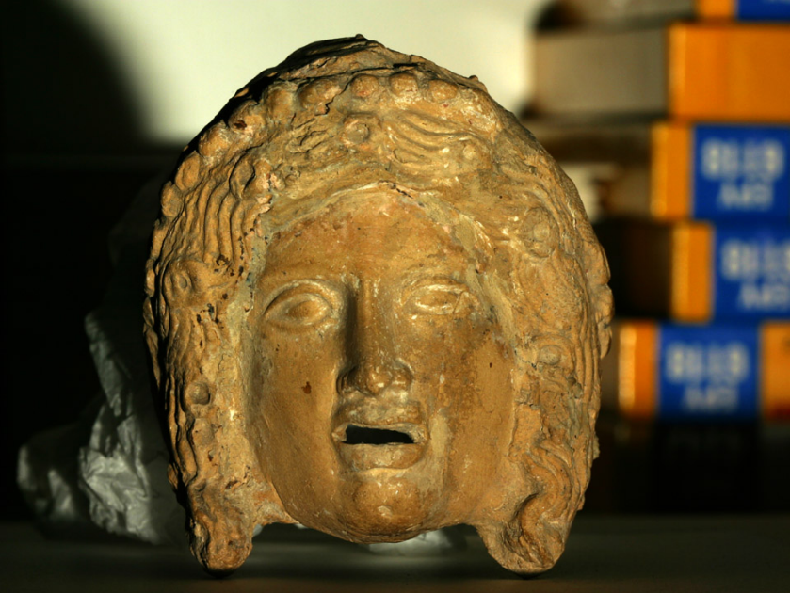

Fig.13 Female mask from Lipari, previously identified as the Golden Hetaira of New Comedy, now tentatively to be ascribed to tragedy (Art Gallery and Museum, Kelvingove, Glasgow)

With a second mask – the so-called ‘golden hetaira’ of Kelvingrove from Lipari (Fig. 13) – the components are likewise revealing of how the grotesque/idealised opposition applies to the female masks, with results that are varyingly consistent with the archaeological evidence. The ‘short and fat’ shape that is at one extreme of Component 5 (Fig. 14) changes this composed and culturally-approved face into a grotesque that evokes certain of the New Comedy masks of old women such as Brea’s oikuron graidion (Brea 1981, 212f), and also his earlier types C6 and C7 (Brea 1981, 53-5). Component 4, however, creates a face that would be an interesting and viable character mask (Fig. 15), but animated by emotions (glee, triumphalism, self-satisfaction) that do not seem permitted to female characters in the ancient theatre.
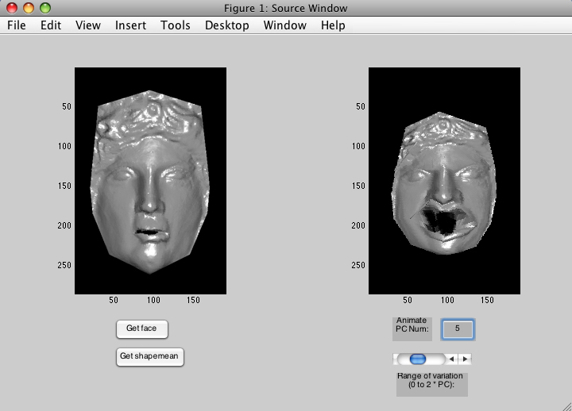

Fig. 14 The mask from Fig. 13 mapped to the average of the dataset (left) and to the negative extreme of Component 5 (right)

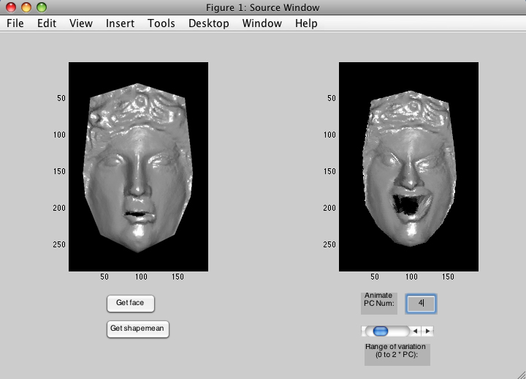

Fig. 15 The mask from Fig. 13 mapped to the positive extreme of Component 4 (right)

With the Kelvingrove youth previously discussed (Fig. 2 above), the components arguably reveal some of the secret fears of the elite social groupings. As with the previous mask, mapping the texture to the average co-ordinates produces a very neutral, lifeless face, which is neither aesthetic nor especially alert. The negative end of the Component 1 is aestheticised and attentive (Fig. 16), very similar to the artefact, if perhaps slightly feminised and more naïve. The positive end of the same Component, however, makes an alarming and unfamiliar face out of this noble countenance (Fig. 17). The slave co-ordinates break through as they did with the tragic mask, but whereas an old man of tragedy maps easily onto the servile facial structure – for the slaves of ancient drama are bearded and relatively aged – the impression here is of a demonic face, reminiscent of certain carnival masks. The structuralist interpretation of David Wiles (1991), following that of Levi-Strauss, posits that the taxonomy of the masks is such that the qualities absent from a given mask are to be perceived by their absence. The extremes of Component 1 in this case are a vivid demonstration of how the mask could be transformed by qualities that are lacking from it, but present in the dataset. It would be superfluous to present the lower order components individually, but the positive extreme of Component 3 (Fig.18) is another example which has qualities that are not only grotesque and demonic, but perceptibly mean and (it might be thought) evil. But these are qualities that are notably absent from the repertoire of the ancient masks – both comic and tragic. We thus arrive through the use of PCA at forms that lie outside the stylistic ‘envelope’ of the masks of antiquity, but are derived from factors latent within the dataset of those masks. Through the application of successive Components to individual masks the parameters of the ancient maskmakers’ visual grammar may be laid bare, even when they choose not to exploit them to their fullest extent, creating masks that might be found in one or other of the Asiatic traditions, but are deliberately eschewed in that of Greco-Roman Antiquity.

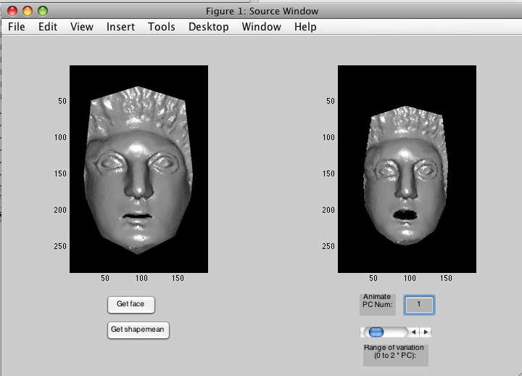

Fig. 16 The mask from Fig. 2 mapped to the average of the dataset (left) and to the negative extreme of Component 1 (right)

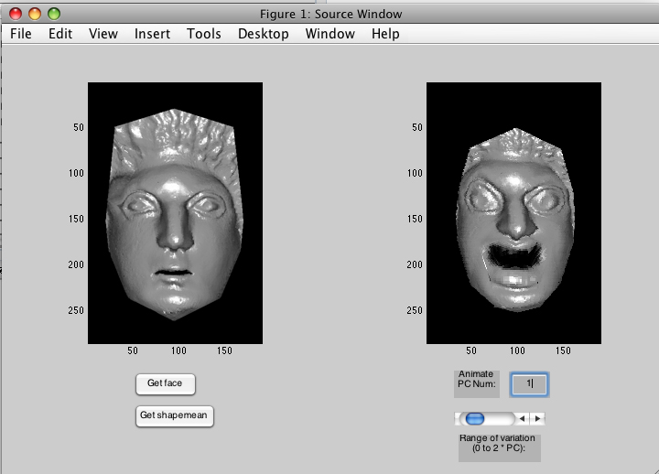

Fig. 17 The mask from Fig. 2 mapped to the negative extreme of Component 1 (right)

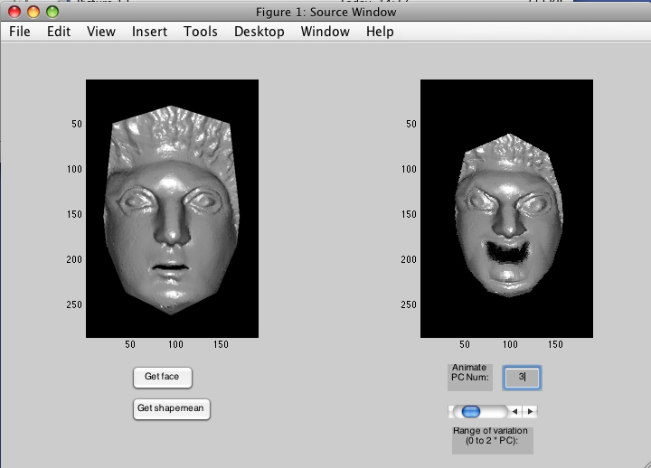

Fig. The same mask mapped to the positive extreme of Component 3 (right)

References:

Brea, L. Bernabo, (1981) Menandro e il teatro Greco nelle terracotta liparesi, Genova.

Bruce, V. and Young, A. (1998) In the Eye of the Beholder: the science of face perception, Oxford.
Calder, A.J., Young, A.W., Rowland, D. and Perrett, D.I. (1997) ‘Computer-enhanced emotion in facial expressions’, Proceedings of the Royal Society: Biological Sciences, B264, 919-25.

Ekman, P. and Friesen, W.V. (1978) Facial Action Coding System, Consulting Psychologists Press, Palo Alto, California.

Hjortsjö, C.-H. (1969), Man’s face and mimic language, Studentlitteratur, Malmö

Wiles, D. (1991) The Masks of Menander: sign and meaning in Greek and Roman performance, Cambridge, Cambridge University Press

